FIFTEEN SHARDS OF LIGHT
Level_02 — Живой свет
GAMEPLAY MAP AND COMPLETE LEVEL DESIGN SPECIFICATION
Direct production input for Producer • Godot Tech • Art / Blender • Codex
DOCUMENT STATUS
Final gameplay and spatial specification for pre-greybox approval. No Godot implementation is included in this deliverable.

Source visual package: Level_02_Visual_Master_Concept_Package.docx, Version 1.0

1 Final Level Design Verdict
Decision, visual-source alignment, conflicts and minimal gameplay corrections
FINAL VERDICT — APPROVE WITH MINIMAL READABILITY ADJUSTMENTS
The 1+3 circular-platform concept, two order-independent light trials, two Soul Shards, staged color/fog progression and center portal are suitable for greybox. The layout is production-realistic for a small polished 3D mini-novella, provided the readability safeguards below are treated as hard requirements.

Source-of-truth hierarchy
- Narrative lock and hard constraints in this specification.
- Text, tables and technical diagrams in the approved Visual Master Concept Package.
- Exact coordinates, state machines, timing and acceptance criteria in this gameplay specification.
- AI concept-board imagery remains mood/reference only and cannot override coordinates, collision or interaction rules.
Visual concept vs gameplay readability — detected conflicts and minimal corrections
Conflict | Gameplay risk | Minimal correction
Perfect 120° symmetry | Can read as a boss arena and make Trial A/B silhouettes interchangeable. | Keep the gameplay geometry, but offset platform heights, use different hero silhouettes, and break only secondary masses with foliage/ruins.
75–85% desaturation + dense fog | Can hide both route entrances and make the free choice unreadable. | Keep route surfaces and emissive channels readable; initial fog must reveal the central near edge and both route entrance silhouettes from the central arena.
Trial A shell H 4–5 m | Can occlude statues and feel like an altar. | Use H 4.2 m, R 2.1 m, segmented/open-top silhouette, and no raised stairs or worship axis.
Trial B bud up to R 3.5 m | May compress the pad circulation ring. | Use R 2.7 m, pads at R 5.0 m, active diameter 2.3 m, leaving ≥2.0 m outer camera/safety clearance.
Final central spectacle | Can become a long non-interactive cutscene. | All color/fog/spiral transitions remain non-blocking; movement is blocked only while the existing text overlay is open.

Locked narrative text
Element | Locked text
Shard A | «В тебе есть свет, который не нужно делать громче».
Shard B | «Рядом с мыслью о тебе во мне больше жизни».
Main level text | «Мне дорого, что в тебе есть свой свет - иногда яркий, иногда совсем тихий. Его не нужно делать громче или превращать во что-то другое. Мне нравится, что он твой. И рядом с мыслью о тебе во мне становится больше жизни».

2 Exact Gameplay Map
World-coordinate convention and final spatial proposal
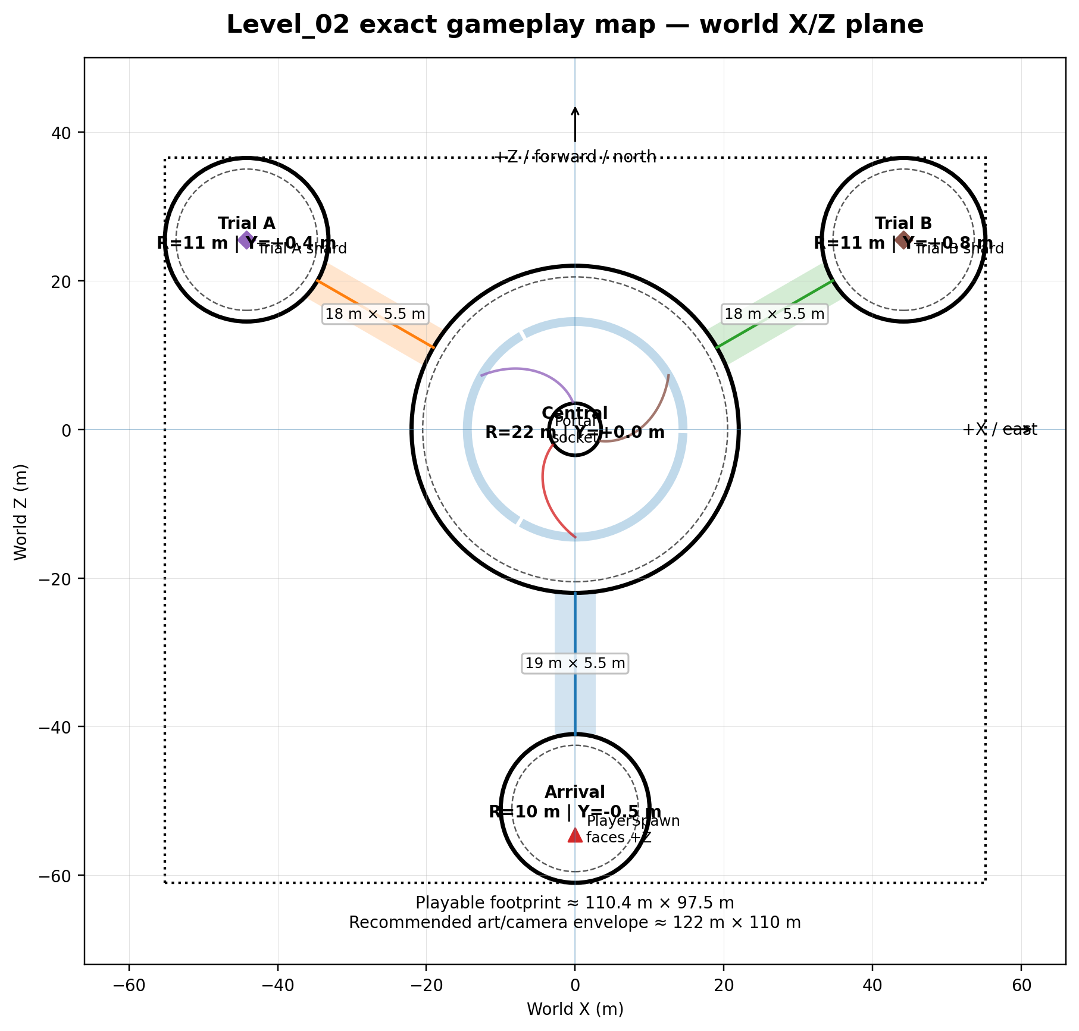
Figure 1. Exact top-down gameplay map. Coordinates use the Godot X/Z ground plane; Y is vertical.
WORLD COORDINATE CONVENTION
Central arena center = Vector3(0, 0, 0). World +Z is level-forward / north from Arrival toward the center. World +X is east / right. Azimuth is measured clockwise from +Z. Player arrives south of center and initially faces +Z.

3 Dimensions and Coordinates
Production values for greybox, collision and art wrappers
Area | Center coordinate | Azimuth | Physical radius | Usable radius | Notes
Central arena | Vector3(0.00, 0.00, 0.00) | — | 22.0 m | 20.0 m | Main landmark; 2.0 m decorative/safety rim
Arrival platform | Vector3(0.00, -0.50, -51.00) | 180° | 10.0 m | 8.5 m | PlayerSpawn at Vector3(0.00, -0.30, -54.50)
Trial A | Vector3(-44.17, 0.40, 25.50) | -60° / 300° | 11.0 m | 9.5 m | Three Beams; shell at platform center
Trial B | Vector3(44.17, 0.80, 25.50) | 60° | 11.0 m | 9.5 m | Echo of Light; bud at platform center

Route | Central entrance | Outer entrance | Length | Width | Slope
Arrival route | Central edge Vector3(0.00, 0.00, -22.00) | Arrival edge Vector3(0.00, -0.50, -41.00) | 19.0 m | 5.5 m | 1.5° nominal; hard max 8°
Trial A route | Vector3(-19.05, 0.00, 11.00) | Vector3(-34.64, 0.40, 20.00) | 18.0 m | 5.5 m | 1.3° nominal; hard max 8°
Trial B route | Vector3(19.05, 0.00, 11.00) | Vector3(34.64, 0.80, 20.00) | 18.0 m | 5.5 m | 2.5° nominal; hard max 8°

Marker | Coordinate | Volume / size | Rule
Central socket | Vector3(0.00, 0.05, 0.00) | R 3.5 m | Floor-integrated; no pedestal
Central activation zone | Vector3(0.00, 0.50, 0.00) | Cylinder R 5.2 m, H 2.5 m | Starts final sequence only after both shards and fog transition readiness
Shard A spawn | Vector3(-44.17, 2.00, 25.50) | Trigger initially disabled | Activates after shell reveal completes
Shard B spawn | Vector3(44.17, 2.30, 25.50) | Trigger initially disabled | Activates after bud reveal completes
Portal visual center | Vector3(0.00, 2.20, 0.00) | Approx. W 3.6 m × H 4.0 m | Forms after main text closes
Portal trigger | Vector3(0.00, 1.70, 0.00) | Capsule/cylinder R 2.2 m, H 3.4 m | Enabled only on formation_complete

Footprint, boundaries and camera safety
- Playable geometry envelope: approximately 110.4 m (X) × 97.5 m (Z).
- Recommended art/camera envelope: approximately 122 m × 110 m, including 6 m of secondary dressing and camera clearance.
- Route collision width = 5.5 m; visually clear walking width must never fall below 5.0 m.
- High props (>1.8 m) stay at least 3.5 m from route centerlines and at least 2.5 m from puzzle interaction points.
- Physical boundary rim: 1.5–2.0 m between usable play area and the outer platform edge.
- Invisible blockers sit 0.35–0.60 m inside the visual rim and follow its curvature; no blocker may cut across a light channel.
4 Sightlines, Preview Points and Navigation Readability
Third-person camera guidance without UI arrows
Preview anchor | Camera position | Look target | Use
Preview_Arrival | Vector3(0.00, 5.20, -58.00) | Vector3(0.00, 1.00, -6.00) | Optional ≤1.0 s soft emphasis; never a long lock
Preview_CenterChoice | Vector3(0.00, 7.00, -9.00) | Vector3(0.00, 1.00, 11.00) | Both trial silhouettes must fit 16:9 view
Preview_TrialA | Vector3(-37.24, 5.00, 21.50) | Vector3(-44.17, 1.60, 25.50) | Shows all three statues and central shell
Preview_TrialB | Vector3(37.24, 5.40, 21.50) | Vector3(44.17, 1.40, 25.50) | Shows all four pads and central bud
Preview_FinalCenter | Vector3(0.00, 7.50, -10.00) | Vector3(0.00, 2.80, 0.00) | Optional short framing before main text; player movement remains active

Hard readability rules
- From PlayerSpawn, the arrival channel and near silhouette of the central arena are always visible.
- From the central arena choice band (R 10–18 m), Trial A and Trial B must be simultaneously readable as different silhouettes.
- Trial A landmark = three separated vertical lens-statues around a tall segmented shell.
- Trial B landmark = low four-petal bud plus four large floor shapes; it must never resemble the Trial A shell.
- The central socket remains visible in the background from each trial through the route opening or channel alignment.
- Initial fog may obscure decorative distance, but not the full width of any mandatory route or the first 8 m of either trial route.
- Active light channels are built into floors and never behave like floating arrows.
Return guidance triggers
Trigger | Coordinate | Volume | Behavior
ReturnGuide_A | Vector3(-34.64, 1.10, 20.00) | Box 5.5 × 2.5 × 3.0 m, oriented to route | After second shard, crossing or standing near it intensifies particles flowing toward center.
ReturnGuide_B | Vector3(34.64, 1.50, 20.00) | Box 5.5 × 2.5 × 3.0 m, oriented to route | Same behavior; idempotent and non-blocking.
CenterChoiceBand | Annulus R 10–18 m around center | No collision | Keeps both branch channels at equal idle intensity until first choice.

5 Complete Beat-by-Beat Level Flow
Target first completion 6–8 minutes; acceptable maximum 10 minutes
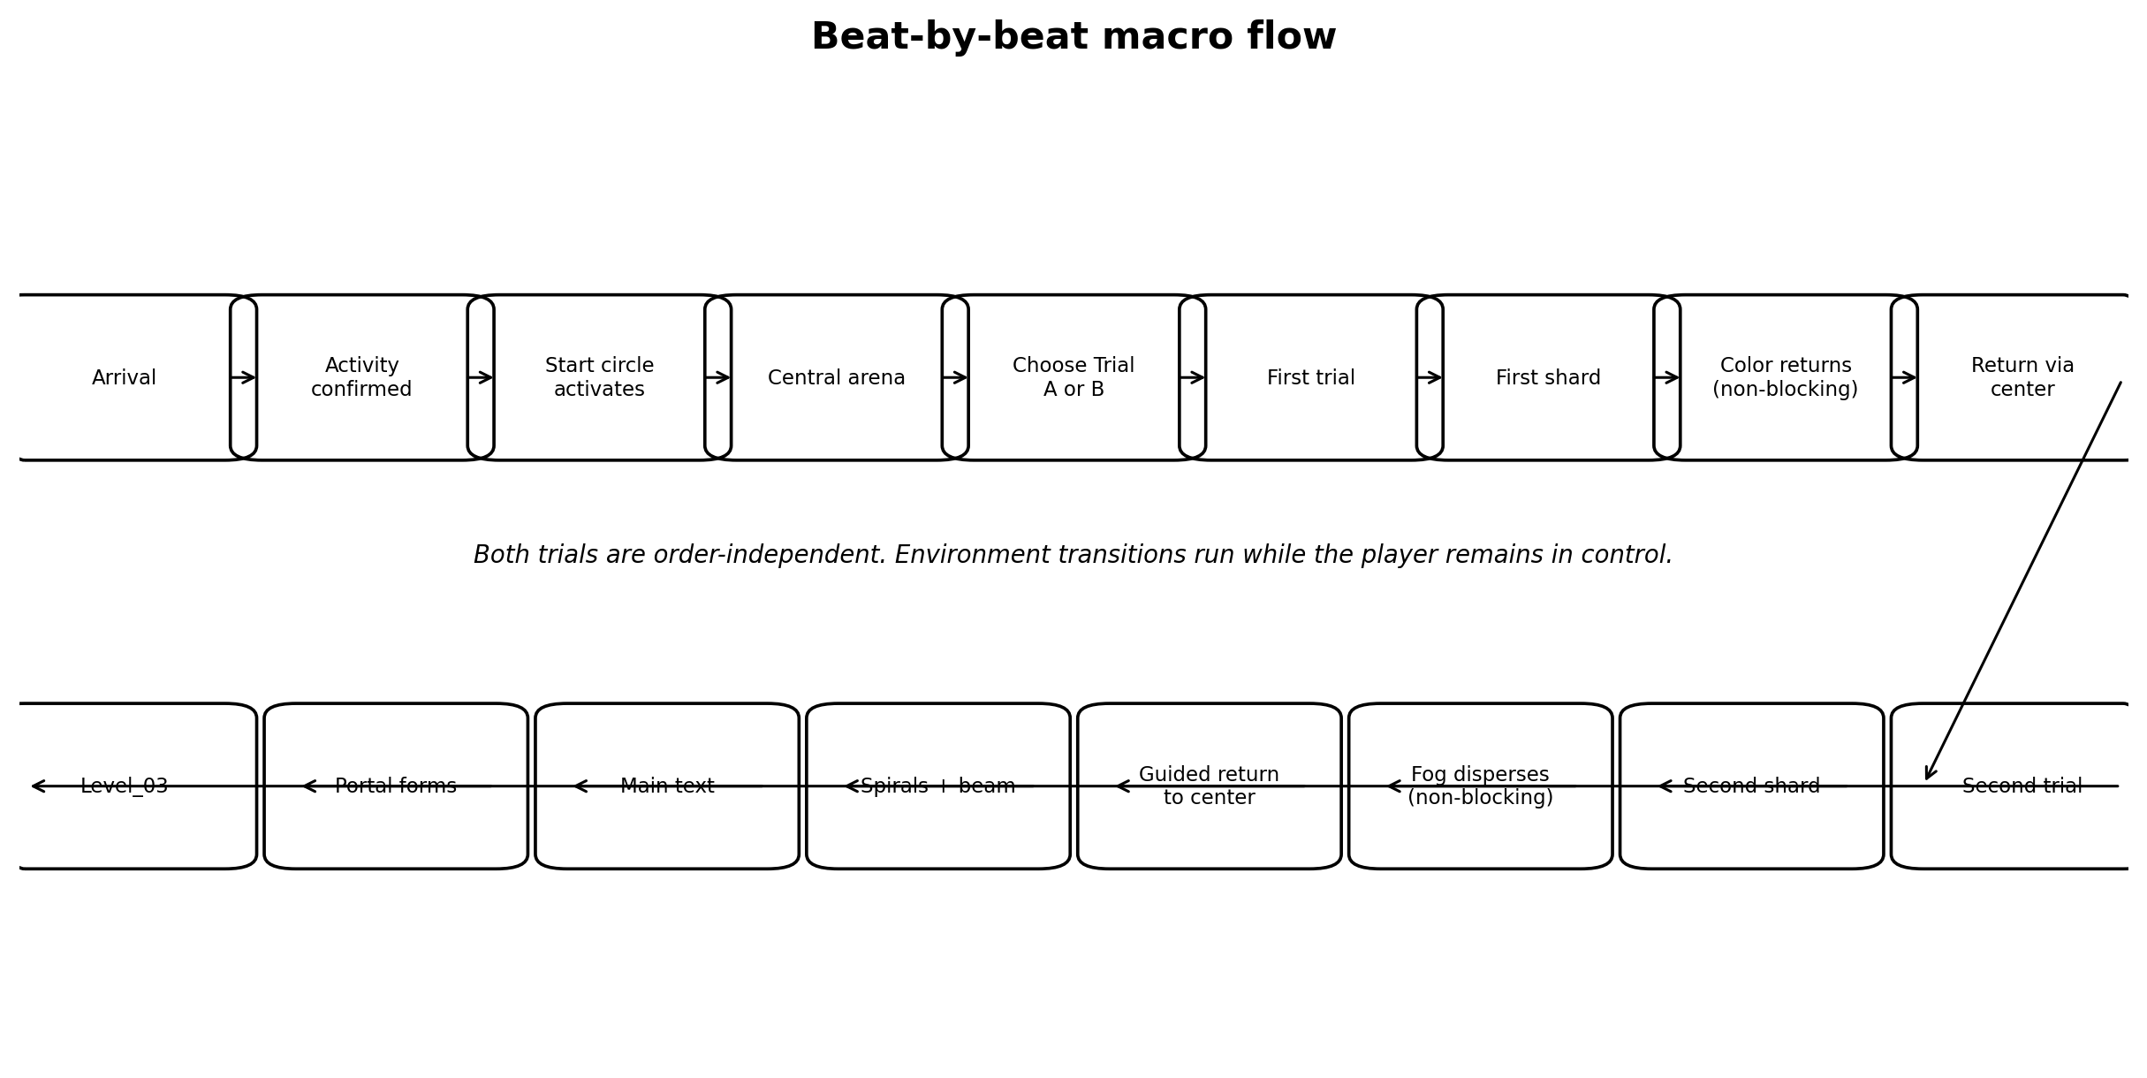
Figure 2. Macro player flow. Trial A and Trial B occupy the same order-independent branch.
Beat | Location | Goal | Landmark | Time | Action | Narrative | VFX / env | Confusion | Fallback
1. Arrival | PlayerSpawn on Arrival | Orient toward center | Central arena silhouette | 10–15 s | Move / look | Quiet light already exists | Low ambient channel glow | Fog feels too close | Arrival route surface and channel remain fully visible
2. Activity confirmation | Arrival inner circle | Confirm control | Inactive floor circle | 2–5 s | First movement or camera input | Agency begins the chapter | Soft pulse under feet | Player stands still | Auto-confirm after 4 s idle
3. Start activation | Arrival circle | Read cause/effect | Channel to center | 3–4 s | Observe while moving | Light becomes legible | Circle → route channel → start sector | Looks like cutscene | No control lock; animation follows player
4. First sight of center | Arrival route | Reach landmark | Central ring silhouette | 10–15 s | Walk forward | Space opens without danger | Fog rim catches warm light | Center lost in fog | Start channel brightness + clear route corridor
5. Enter central arena | South entrance | Understand hub | Portal socket + 3 sectors | 8–12 s | Cross ring threshold | The level is one connected mechanism | Start sector remains lit | Player circles rim | Socket pulse and open sightlines
6. Read both directions | Choice band | Choose freely | Trial A statues / Trial B bud | 8–15 s | Turn camera / approach branch | No morally correct order | Equal idle pulses on both unsolved channels | One branch looks mandatory | Matched initial brightness and equal route width
7. Select first trial | Chosen route | Reach puzzle | Trial silhouette | 15–25 s | Traverse safe route | Following visible light | Chosen route reacts subtly | Player turns back | Choice remains reversible; no doors close
8. Complete first trial | Trial platform | Reveal shard | Puzzle hero object | 45–130 s | Rotate statues or repeat sequence | Attention to light | Local progress feedback | Puzzle rules unclear | Layered assistance; no punishment
9. Collect first shard | Trial center | Read phrase | Soul Shard | 12–20 s | Interact / collect | First emotional statement | Shard phrase overlay | Collect before reveal done | Trigger disabled until reveal_complete
10. Color restoration | Anywhere after phrase | Continue moving | World palette | 8–10 s background | Free traversal | Clarity and inner vitality | Saturation returns; fog -5–10% | Player expects lock | No camera/control lock

Beat | Location | Goal | Landmark | Time | Action | Narrative | VFX / env | Confusion | Fallback
11. Return through center | Completed route → hub | See progress + remaining branch | Lit sector/channel | 15–25 s | Walk | First memory remains present | Completed channel stays lit | Player re-enters solved trial | Solved trial landmark goes calm; unsolved channel pulses
12. Select second trial | Central choice band | Take remaining branch | Only unsolved branch pulses | 8–15 s | Choose / traverse | Completion without compulsion | Contrast active vs unsolved | Player thinks first trial reset | Solved puzzle remains visibly open
13. Complete second trial | Remaining platform | Reveal second shard | Remaining hero object | 45–130 s | Puzzle action | Second emotional statement | Local completion | Leaves midway | Runtime progress preserved
14. Collect second shard | Trial center | Read phrase | Second Soul Shard | 12–20 s | Collect | More life / response | Phrase overlay, then center reacts | Duplicate signal | Per-shard idempotent flag
15. Fog dispersal | Anywhere after phrase | Reveal whole level | Distant center | 6–8 s background | Free movement | World becomes fully legible | Fog normalizes; second channel lights | Player waits in place | Return particles + center sound beacon
16. Guided return | Second trial → center | Return to hub | Thin vertical center shimmer | 15–25 s | Traverse | Both lights now converge | Particles flow inward | Player explores outer rim | Persistent center beam, sound and bright route channel
17. Final activation | Central R 5.2 m zone | Complete spiral | Three branch lines | 5–6 s | Enter zone; remain free | Separate lights become one path | Spirals fill; thin beam rises | Player exits zone | Sequence never cancels once started
18. Main text | Central area | Read chapter statement | Stable vertical beam | 15–30 s | Close overlay | Explicit emotional meaning | Ambient motion continues | Overlay closes unexpectedly | Close event idempotent; portal still forms once
19. Portal formation | Center socket | Provide exit | Warm portal + particles | 2.5–3.5 s | Free movement nearby | A new path opens | Beam condenses into portal | Player enters too early | Collision remains disabled until formation_complete
20. Transition | Portal trigger | Load Level_03 | Portal core | 2–5 s | Enter portal | Continue story | Soft fade / scene change | Multiple body_entered | Transition latch accepts one request

DURATION BUDGET
Normal first completion: 6–8 minutes. Acceptable maximum with mistakes/exploration: 10 minutes. Correct repeat completion: approximately 4–6 minutes. Trial B is intentionally the longer trial.

6 Trial A — Three Beams
Exact layout, rules, feedback, persistence and assistance
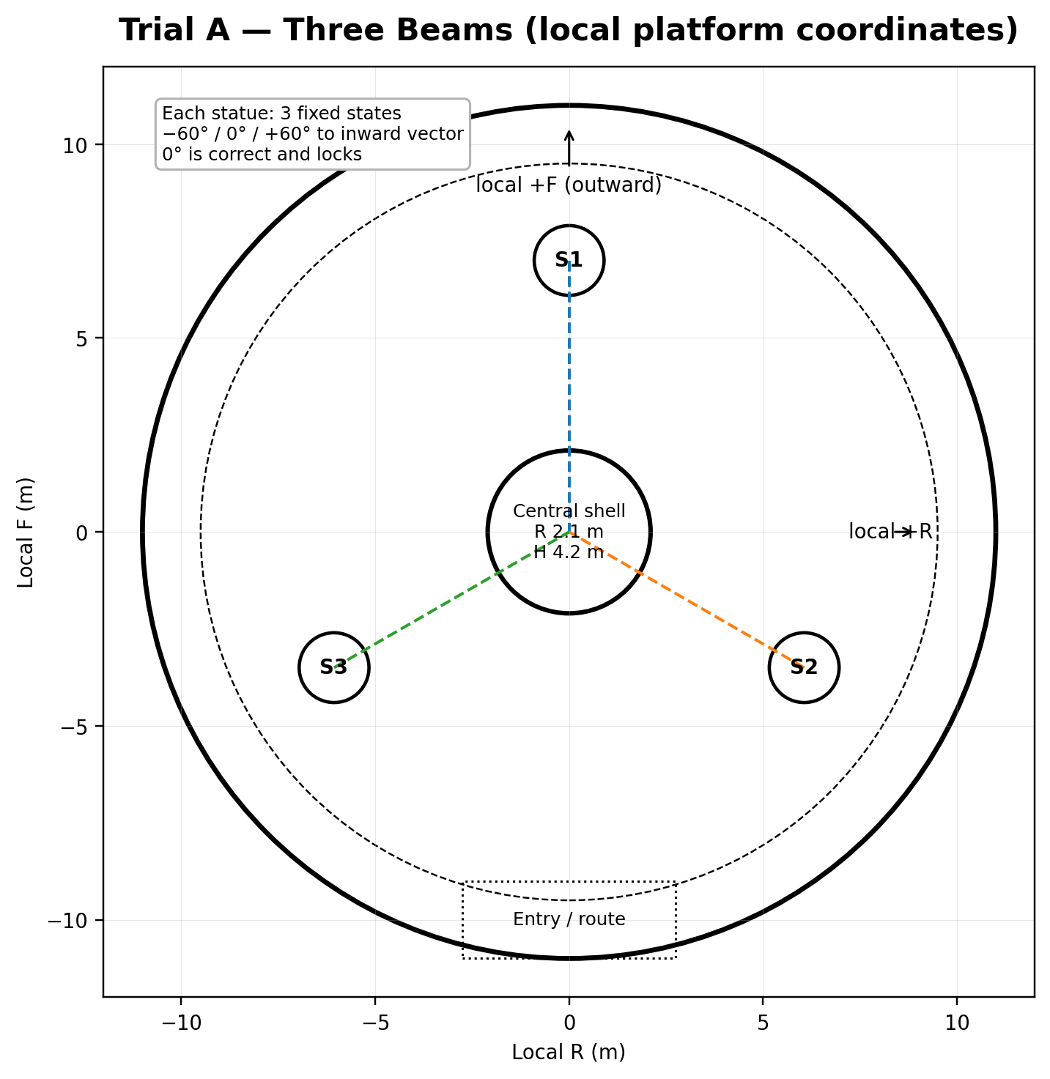
Figure 3. Trial A local layout. World positions are derived from the platform transform and listed below.
Object | Local coordinate | World coordinate | Initial condition
Statue A1 | Local (R 0.00, F +7.00) | Vector3(-50.23, 0.40, 29.00) | Initial state 0; 1 press to correct
Statue A2 | Local (R +6.06, F -3.50) | Vector3(-38.11, 0.40, 29.00) | Initial state 2; 2 presses to correct
Statue A3 | Local (R -6.06, F -3.50) | Vector3(-44.17, 0.40, 18.50) | Initial state 0; 1 press to correct
Central shell | Local (0, 0) | Vector3(-44.17, 0.40, 25.50) | R 2.1 m; H 4.2 m

7 Trial A Mechanical Specification
Deterministic three-state interaction with no reset
Orientation model
State | Orientation | Validity | Feedback
State 0 | -60° from the inward vector | Incorrect bypass left | Visible beam passes left of shell; neutral lens tone
State 1 | 0° toward platform center | Correct | Beam hits shell receiver; statue locks permanently
State 2 | +60° from the inward vector | Incorrect bypass right | Visible beam passes right of shell; neutral lens tone

Interaction cycle: State 0 → State 1 → State 2 → State 0, clockwise in top-down presentation. Each statue uses the same relative model; Godot yaw sign is implementation-specific, but the visual order must remain clockwise to the player.
Rule | Specification
Interaction prompt | Shown within 2.2 m, line of sight, while statue is unlocked and not rotating: “E - повернуть источник”.
Rotation | 0.40 s eased rotation to the next fixed state. Beam updates continuously or at ≥70% of the rotation.
Anti-spam | 0.35 s minimum between accepted interactions; input during rotation is ignored, not queued.
Correct lock | Warm 0.4 s pulse, short consonant tone, receiver lights, statue interaction disabled.
Central progress | Shell ring shows 1/3, 2/3, 3/3 through three separate light segments.
Leaving platform | All statue states and locked flags remain unchanged for the current level run.
Re-entering | No intro replay after first entry; unsolved statues remain interactive, solved statues remain locked.
Completion | At 3/3 the shell becomes translucent over 0.8 s, opens/dissolves over 1.4 s, then reveals Shard A.
Shard trigger | Disabled until shell reveal animation emits reveal_complete; cannot be collected early.
Trial completion signal | Emitted once after reveal_complete: trial_solved(TRIAL_A). Shard collection remains a separate event.

Accessibility and confusion fallback
Condition | Assistance
No new lock for 35 s | Each shell receiver pulses in order; the currently nearest unsolved statue lens brightens slightly.
6 rotations without a new lock or 55 s | A 1.5 s faint ghost line previews the inward direction for the nearest unsolved statue.
80 s unresolved | The next unsolved statue pauses 0.7 s when it reaches the correct state before the player can rotate again; no auto-solve.

EXPECTED TIME
First completion: 45–75 seconds. Correct repeat: 20–35 seconds. The puzzle never resets solved statues and has no timer.

8 Trial B — Echo of Light
Exact pad layout and cumulative fixed sequence
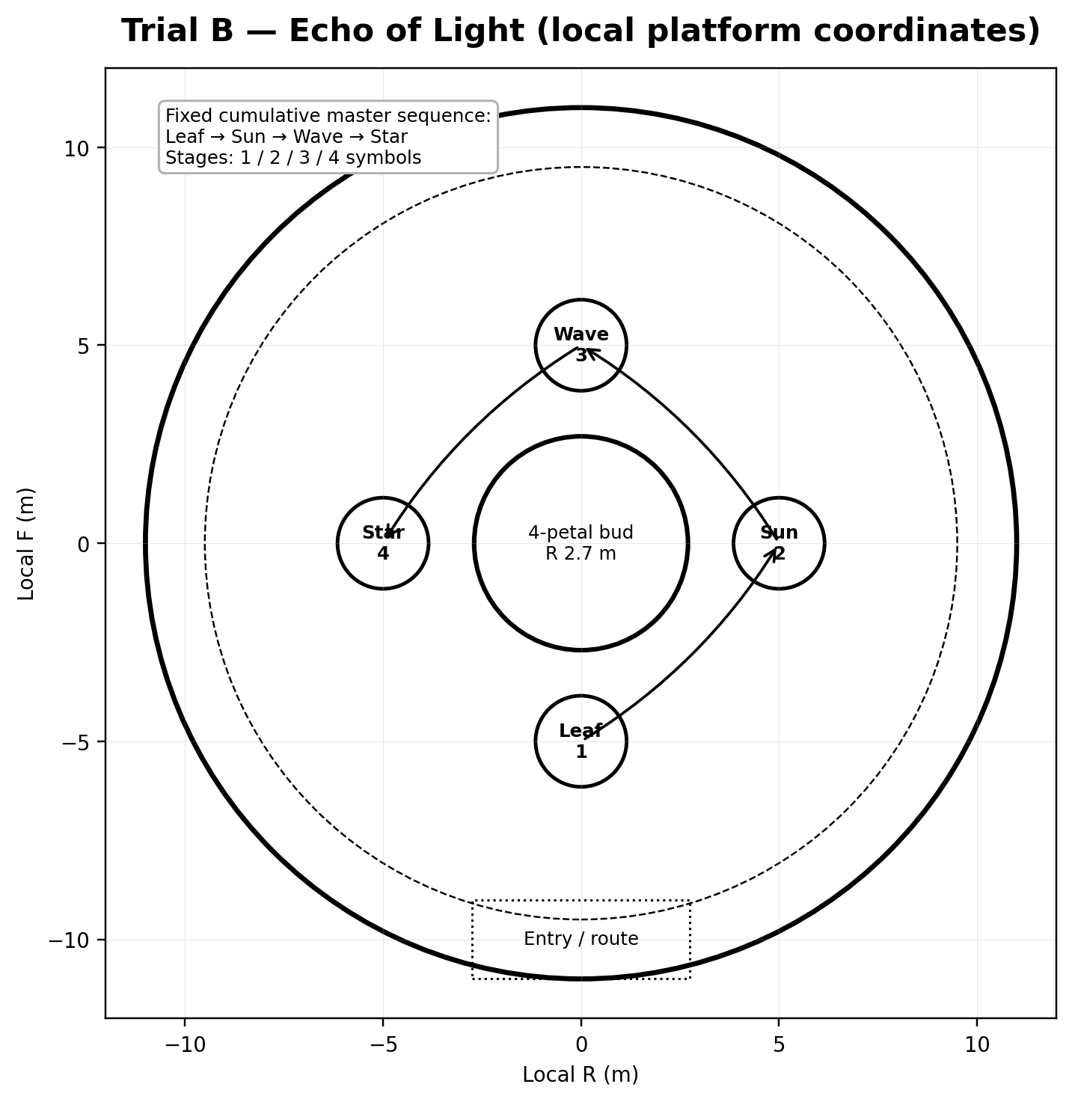
Figure 4. Trial B local layout. The sequence forms a clear clockwise movement loop from the entry-side Leaf pad.
Object | Local coordinate | World coordinate | Role
Leaf | Local (R 0.00, F -5.00) | Vector3(39.84, 0.80, 23.00) | Stage 1 symbol; closest to entry
Sun | Local (R +5.00, F 0.00) | Vector3(46.67, 0.80, 21.17) | Second symbol
Wave | Local (R 0.00, F +5.00) | Vector3(48.50, 0.80, 28.00) | Third symbol
Star | Local (R -5.00, F 0.00) | Vector3(41.67, 0.80, 29.83) | Fourth symbol
Central bud | Local (0, 0) | Vector3(44.17, 0.80, 25.50) | R 2.7 m; 4 persistent petals

9 Trial B Mechanical Specification
Four cumulative stages with persistent progress
Locked master sequence and symbols
Symbol | Silhouette | Internal pattern | Audio cue | Color support
1. Leaf | Drop / leaf silhouette | Central vein + two side veins | Low organic chime | Soft green-gold accent
2. Sun | Circle with short rays | Warm central core | Clear warm bell | Amber accent
3. Wave | Two S-curves | Parallel flowing lines | Soft water-glass tone | Peach / muted blue accent
4. Star | Four- or eight-point star | Central diamond | High airy chime | Ivory-gold accent

Stage | Displayed / entered sequence | Persistent result | Input count
Stage 1 | Leaf | 1st petal opens | 1 symbol
Stage 2 | Leaf → Sun | 2nd petal opens | 2 symbols
Stage 3 | Leaf → Sun → Wave | 3rd petal opens; shard glow becomes visible | 3 symbols
Stage 4 | Leaf → Sun → Wave → Star | 4th petal opens; full reveal | 4 symbols

Timing and input rules
Parameter | Value
Normal symbol glow | 0.75 s
Normal gap | 0.40 s
Assisted symbol glow | 1.20 s
Assisted gap | 0.60 s
Intro pulse | 1.00 s
Error settle before replay | 0.80 s
Stage success transition | 1.20 s
Final bud reveal | 2.40 s

Rule | Specification
Pads during SHOWING_SEQUENCE | Disabled. body_entered events are ignored and never queued.
Activation | A pad accepts input only in WAITING_FOR_INPUT and only when armed.
Step-off requirement | After activation, that pad remains unarmed until body_exited or player center is >1.35 m from pad center.
Player standing on a pad when input phase begins | That occupied pad begins unarmed; player must step off and re-enter.
Correct input | Pad pulses, current input index increments, short symbol audio plays.
Wrong input | Current stage input index resets to 0; completed petals remain open.
Manual replay | Within 2.5 m of the bud during WAITING_FOR_INPUT: “E - повторить последовательность”. Input index resets and current stage replays without penalty.
Leaving platform | Completed stages, open petals and current stage persist. An incomplete current input is cleared, then the stage replays on re-entry.

10 Trial B State Machine
Runtime states, transitions and layered assistance
State | Responsibility | Exit condition | Next state
IDLE | Player has not entered inner trigger | Player enters R 7.5 m | INTRO
INTRO | Bud and pads give one orientation pulse | 1.0 s complete | SHOWING_SEQUENCE
SHOWING_SEQUENCE | Display first N symbols; pads disabled | Sequence complete | WAITING_FOR_INPUT
WAITING_FOR_INPUT | Accept armed pad or manual replay | Correct / wrong / replay | INPUT_SUCCESS / INPUT_ERROR / SHOWING_SEQUENCE
INPUT_SUCCESS | Confirm one correct pad | More symbols remain / stage complete | WAITING_FOR_INPUT / STAGE_SUCCESS
INPUT_ERROR | Soft error pulse; no penalty | 0.8 s | SHOWING_SEQUENCE
STAGE_SUCCESS | Open one persistent petal | 1.2 s | NEXT_STAGE or TRIAL_COMPLETE
NEXT_STAGE | Increment stage, reset stage error count | 0.6 s | SHOWING_SEQUENCE
TRIAL_COMPLETE | Open final petal and reveal shard | reveal_complete | SHARD_AVAILABLE
SHARD_AVAILABLE | Shard trigger enabled | shard collected | Complete / calm state

Condition | Response
First error in current stage | Normal timing replay after 0.8 s; no additional highlight.
Second error | Replay uses assisted timing: glow 1.20 s, gap 0.60 s.
Third and later errors | During WAITING_FOR_INPUT, the next expected pad gives a subtle 15% rim pulse every 2 s and one faint particle drift from bud to pad.
Manual replay | Always available during WAITING_FOR_INPUT and does not count as an error.

EXPECTED TIME
First completion: 90–130 seconds. Correct repeat: 45–70 seconds. The master sequence is fixed in the first playable and never procedural.

11 Free-Order Progression Logic
Single deterministic logic for A→B and B→A
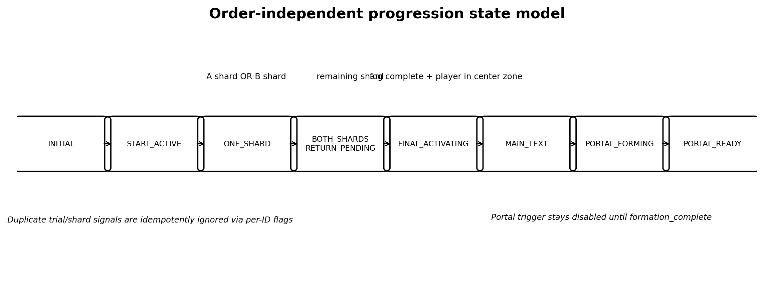
Figure 5. High-level progression. Trial solved, shard available and shard collected are deliberately separate events.
Event | Guard | Result
trial_solved(A/B) | Accepted once per trial | Reveals/records trial completion; does not change global environment before shard collection.
shard_collected(A/B) | Accepted once per shard ID | Sets per-shard boolean, lights matching sector/channel, recomputes count from booleans.
First accepted shard | count changes 0 → 1 | Starts color restoration exactly once; stores first_shard_id only for analytics/debug, not branching content.
Second accepted shard | count changes 1 → 2 | Starts fog dispersal exactly once; sets final_return_pending = true.
Duplicate trial/shard signal | Boolean already true | Ignored with a single debug warning; no repeated VFX, text or counter increment.
Player in central zone before fog completes | Both shards true, fog not ready | Set player_waiting_in_center = true; start final event automatically when fog_ready becomes true.
Player enters central zone after fog completes | Both shards true, final not started | Start final central activation once.
Spiral effect complete | final_started true | Show main level text once.
Main text closed | main_text_shown true | Start portal formation once.
Portal formation complete | portal_forming true | Enable portal trigger, set PORTAL_READY.

Recommended chapter state enum
INITIAL → START_ACTIVE → ONE_SHARD → BOTH_SHARDS_RETURN_PENDING → FINAL_ACTIVATING → MAIN_TEXT → PORTAL_FORMING → PORTAL_READY → TRANSITIONING.
Required persistent runtime flags
- arrival_activated
- trial_a_solved
- trial_b_solved
- shard_a_collected
- shard_b_collected
- color_transition_started
- color_transition_complete
- fog_transition_started
- fog_transition_complete
- final_return_pending
- final_started
- main_text_shown
- portal_forming
- portal_ready
- transition_requested
12 Environment State Progression
Non-blocking color, fog, floor-light and ambience transitions
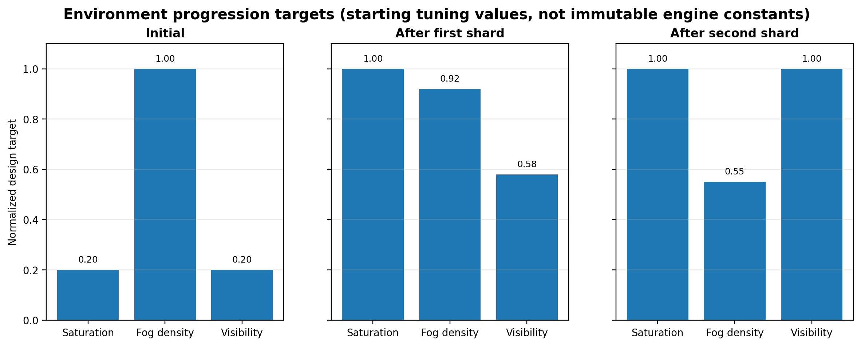
Figure 6. Normalized starting targets. Final Godot parameters require visual calibration, but progression direction is locked.
State | Color target | Fog target | Floor lighting | Particles | Gameplay rule
Initial | 0.20 saturation multiplier (80% reduction) | Fog density 1.00; clear route corridor; effective distance target ~58 m | Start sector + faint route/sector contours | Sparse, muted, slow | World remains alive; mandatory routes readable
After first shard | 0.20 → 1.00 over 9.0 s | Density 1.00 → 0.92; effective distance +5–10% | Completed trial channel/sector permanently active | Warmer and slightly denser | No control or camera lock
After second shard | Saturation remains 1.00 | Density 0.92 → 0.55 over 7.0 s; distance target ~85–90 m | Second channel active; center return cue strengthened | Stable warm particles | Full structure becomes visible; final event still waits for center presence
Portal ready | Normal palette | Normal level fog | All sectors/spirals stable at calm intensity | Portal particles + thin warm core | Avoid gold-everywhere overexposure

Transition implementation contract
- Transitions are parameter interpolation owned by one Level02EnvironmentState controller.
- No duplicate gray material set. Base materials retain real color; desaturation is global/environmental or shader-controlled.
- Player movement, camera and puzzle input stay active throughout color and fog transitions.
- Activated channels remain on as permanent spatial memory.
- Environment callbacks emit color_ready and fog_ready even if the current value was already at target after reload/debug skip.
- The level must remain playable if VFX nodes are absent: progression logic cannot depend on particles or tween completion from optional art nodes.
13 Main Text and Portal Flow
Final central event timing and transition safety
Time | Event | Gameplay rule
0.0 s | Player enters CentralActivationZone with both shards and fog_ready | Final sequence latches; leaving the zone no longer cancels it.
0.0–1.2 s | All three sectors give one calm synchronization pulse | Movement remains active.
1.2–4.2 s | Three spiral branches fill toward center with 0.25 s stagger | No camera lock; optional subtle audio beacon.
4.2–5.5 s | Thin vertical warm beam rises from socket | No damage, knockback or collision.
5.5–6.0 s | Beam stabilizes | Main text overlay opens.
Text open | Existing UI may block movement only while reading | Exact locked main text; close event is idempotent.
After close 0.0–2.8 s | Beam condenses into portal visual; particles settle | Portal trigger remains disabled.
2.8 s | formation_complete | Enable trigger and set target res://scenes/levels/Level_03.tscn.

Locked main text
MAIN LEVEL TEXT
«Мне дорого, что в тебе есть свой свет - иногда яркий, иногда совсем тихий. Его не нужно делать громче или превращать во что-то другое. Мне нравится, что он твой. И рядом с мыслью о тебе во мне становится больше жизни».

Portal safety contract
- Portal visual and portal collision are separate nodes.
- The trigger is disabled in INITIAL through PORTAL_FORMING.
- The first valid body_entered sets transition_requested before requesting scene change.
- Further body_entered signals are ignored.
- If main text close is received twice, only the first call may start portal formation.
- If the portal animation node is missing, a 3.0 s guarded fallback timer enables the trigger and logs a warning rather than softlocking.
14 Guidance System Without Arrows
Diegetic navigation hierarchy and fallback cues
Priority | System | Function | Rule
Primary | Floor light channels | Continuous route connection from platform circles to central sectors | Always readable in initial fog; never floating
Primary | Silhouette landmarks | Trial A = three vertical statues; Trial B = low bud and four floor pads | Visible from center choice band
Secondary | Active sector lighting | Shows completed branch and remaining unsolved branch | Completed stays steady; unsolved gently breathes
Secondary | Open sightlines | Routes open toward hub and preserve center background reference | No high props inside camera safety margin
Final return | Central shimmer / thin beam | Visible from either trial after second shard | Begins distant and non-blocking
Final return | Particle flow | Moves from completed platform through channel toward center | Subtle; does not replace geometry readability
Final return | Spatial audio | Soft center-resonance increases when facing/approaching hub | No spoken instruction required
Contrast | Active vs inactive routes | Idle unsolved channel pulses; solved route becomes calm | Avoid equal high brightness everywhere

Forbidden navigation dependencies
- Minimap
- Compass
- Floating arrows
- Quest markers
- Mandatory text instructions for route choice
- Camera takeover longer than 1.2 s
Readability acceptance thresholds
- In a 16:9 1080p capture from central choice position, both trial route entrances occupy at least 35 px width and are not fully occluded.
- At least one distinguishing landmark element of each trial is visible from the central arena before choosing.
- From each trial platform, the return route entrance and either the central socket or its active channel are visible without rotating more than 120°.
- No mandatory interaction prompt competes with a navigation cue in the same screen corner or focal area.
15 Softlock and Failure Matrix — Part I
Prevention, fallback and acceptance tests
Risk | Prevention | Fallback | Acceptance test
Player enters A then B / B then A | Per-ID booleans; count derived from booleans | Same global states regardless of order | Complete both orders; compare final flags and visuals
Player leaves Trial A halfway | Statue states stored in trial controller | Re-entry resumes exact states; locked statues remain locked | Rotate two statues, leave, return; progress unchanged
Player leaves Trial B halfway | Completed stage/petals persist; partial input cleared | On re-entry replay current stage | Complete Stage 2, enter 2/3 inputs of Stage 3, leave/return
Player triggers pad during replay | Pads disabled in SHOWING_SEQUENCE; no queued input | Occupied pad remains unarmed until step-off | Stand on lit pad during replay; no input accepted afterward until exit/re-enter
Player remains on a symbol pad | Occupancy latch + body_exited requirement | Pad cannot auto-repeat when WAITING begins | Remain on pad through phase change; no activation until step-off
Player collects shard before reveal finishes | Shard trigger disabled until reveal_complete | Guarded fallback timer only if reveal signal missing | Stand inside spawn point before reveal; collection cannot occur early
Duplicate shard signal | Per-shard collected flag checked before processing | Ignore duplicate and log once | Emit same signal twice; count/environment/text unchanged after first

16 Softlock and Failure Matrix — Part II
Traversal, final sequence, reload and transition risks
Risk | Prevention | Fallback | Acceptance test
Player does not return to center | Persistent central shimmer, particles, sound and lit channel | No timeout or teleport; final event waits safely | Remain on trial for 2 min; state stable, center guidance persists
Player enters center before fog completes | Queue player_waiting_in_center | Start automatically when fog_ready if player still inside; otherwise on next entry | Sprint to center during transition; final starts once and not early
Main text closes unexpectedly / twice | Idempotent close handler | First valid close starts portal; duplicate ignored | Send close signal twice and during animation
Portal visual appears before collision ready | Trigger separate and initially disabled | Enable only on formation_complete or guarded fallback timer | Walk into forming visual; no transition until ready
Player falls from a route | Curved blockers + broad safety collision under routes | SoftReturnVolume below Y = -6 moves to nearest SafeAnchor with 0.3 s fade; no death | Force player below each route; recover within 1 s, no state loss
Player walks around visual boundaries | Blockers 0.35–0.60 m inside rim; decor supports boundary reading | Outer catch volume returns player to nearest platform anchor | Attempt full circumference traversal at each platform
Scene reload during partial completion | MVP rule: clean deterministic reset unless project save system explicitly supports level persistence | Optional restore adapter reapplies flags/visual states instantly; no half-animation restore | Reload after each stage; observe either clean reset or fully consistent restore
Missing optional VFX node | Core controller uses explicit NodePaths with null-safe visual adapters | Progress still advances; warning logged; fallback timers fire | Disable particles/beam mesh and complete level
Transition request fires multiple times | transition_requested latch set before scene load call | All later trigger entries ignored | Enter/exit trigger rapidly; only one Level_03 request

MVP RELOAD DECISION
Unless an existing save/checkpoint system is already approved for this project, scene reload may reset Level_02 completely. A clean reset is acceptable; a partially restored or contradictory state is not.

17 Acceptance Criteria — Layout, Navigation and Trials
Greybox gate before Blender hero production
Area | Acceptance criterion
Layout | Central center is (0,0,0); outer centers and radii match the coordinate table within ±0.25 m.
Layout | Playable footprint remains within approximately 112 × 100 m before optional distant dressing.
Layout | No mandatory gap; all routes have ≥5.0 m clear width and hard slope ≤8°.
Layout | Height delta across playable platforms remains ≤1.3 m in the approved proposal and never exceeds 2 m.
Navigation | Both trial route entrances and distinct silhouettes are readable from central choice band.
Navigation | Initial fog never hides the entire width of a mandatory route.
Navigation | No minimap, compass, floating arrow or quest marker is required.
Trial A | Exactly three statues, exactly three fixed orientations, one correct inward state each.
Trial A | Correct statues lock; leaving/re-entering never resets solved statues.
Trial A | All three beams visibly converge and reveal Shard A only after 3/3.
Trial A | First-time completion is normally 45–75 s without instructions longer than one prompt line.
Trial B | Exactly four distinguishable pads and fixed sequence Leaf → Sun → Wave → Star.
Trial B | Stages are cumulative 1/2/3/4; completed petals never close after errors.
Trial B | Pads are disabled during replay and require step-off before reactivation.
Trial B | Manual E replay is available; third-error assistance is subtle and non-punitive.

18 Acceptance Criteria — Progression, Environment, Text and Portal
Functional and emotional completion gate
Area | Acceptance criterion
Either order | A→B and B→A produce the same final state, with correct corresponding sectors/channels.
Signals | Duplicate trial/shard signals do not increment counts or replay VFX/text.
Shard text | Shard A and Shard B exact locked phrases appear once and are not swapped.
Environment | First shard restores color over 8–10 s without blocking movement/camera.
Environment | Second shard disperses fog over 6–8 s without starting final event remotely.
Return | After second shard, the center is clearly guided by geometry, channel, particles and sound.
Final event | Spiral activation begins once only after both shards, fog readiness and central presence.
Main text | Exact locked main text appears once after spiral/beam completion.
Portal | Portal formation starts only after text closes; trigger enables only after formation completes.
Portal | Target path is exactly res://scenes/levels/Level_03.tscn.
Duration | Normal first completion 6–8 min; exploration/mistakes ≤10 min; repeat 4–6 min.
Tone | Initial world remains alive, readable and non-horror; color return reads as clarity, not resurrection.
Tone | Center does not read as boss arena, temple, altar or worship site.
No softlock | Every listed failure-matrix test passes without death, restart requirement or permanent input loss.
Runtime | No new parser errors, invalid NodePaths, duplicate transition calls or unhandled null visual references.

GREYBOX APPROVAL GATE
Do not begin final Blender hero production until layout, sightlines, both trial loops, either-order progression, fall recovery and total duration pass in a primitive-only playable build.

19 Simplification Fallback
What may be reduced without breaking the approved concept
System | Approved simplification | Non-negotiable retained behavior
Central floor pattern | Use three emissive mesh strips + three ring-sector meshes; no bespoke shader animation required. | Must still light independently and converge to center.
Environment transition | Use one WorldEnvironment adjustment/tween and one fog parameter. | Must remain non-blocking and preserve real material colors.
Trial A shell | Use four primitive segments that hide/scale/dissolve. | Shard remains hidden and reveal timing remains readable.
Trial B petals | Use four separate primitive petal meshes rotating open. | Four cumulative stages and persistent progress remain locked.
Audio | Use one shared light chime with pitch variants. | Symbols must still be distinguishable by shape/location, not audio alone.
Preview cameras | Remove all optional previews. | Sightlines and floor guidance must carry navigation by themselves.
Persistence | Use clean level reset on reload. | No contradictory partial restore state.
Decor | Limit to one ruin kit and foliage clusters. | Do not block routes or make geometry look like a combat arena.

Do not simplify by
- Removing one Soul Shard or one trial.
- Making Trial B procedural/random in the first playable.
- Replacing free order with forced A→B or B→A.
- Using a long cutscene to hide missing gameplay feedback.
- Using UI arrows as the primary navigation solution.
- Increasing punishment, adding timers, damage, death or mandatory jumps.
20 What to Pass to Godot Tech Chat
Scene decomposition, API contracts and implementation order
Scene / node | Responsibility
Level_02.tscn | Composition, explicit NodePaths, player spawn, route/platform wrappers, central activation zone, SafeAnchors.
Level02ProgressController.tscn | Order-independent flags/state enum, idempotent event handling, main text and portal gating.
CentralLightMechanism.tscn | 3 sectors, 3 connection channels, 3 spiral arms, socket, beam adapter; no progression ownership.
TrialA_ThreeRays.tscn | Three statue controllers, shell progress/reveal, Shard A wrapper.
TrialB_LightEcho.tscn | Four pads, bud/petals, state machine, replay interaction, Shard B wrapper.
Level02EnvironmentState.tscn | Color/fog/particle interpolation and color_ready / fog_ready signals.
Level02Portal.tscn | Visual formation, disabled trigger, guarded formation_complete, Level_03 transition latch.
Environment wrappers | Art-only meshes/collision; gameplay API remains stable when art is swapped.

Required signal/API contract
Direction | Signals / calls
Trial controllers → Progress | trial_solved(trial_id), shard_available(shard_id), shard_collected(shard_id)
Environment → Progress | color_ready(), fog_ready()
Central mechanism → Progress | final_visual_complete()
Text UI → Progress | main_text_closed()
Portal → Progress | formation_complete(), transition_requested(target_path)
Progress → visuals | activate_arrival_sector(), activate_trial_sector(id), begin_final_spirals(), form_portal()

Recommended implementation order
- 1. Primitive greybox and collision using exact coordinates.
- 2. Player traversal, boundaries, SafeAnchors and fall recovery.
- 3. Central mechanism wrapper and progression controller skeleton.
- 4. Trial A fully functional with primitive beams and shell.
- 5. Trial B state machine with primitive pads and petals.
- 6. Either-order shard progression and central return gating.
- 7. Environment parameter transitions.
- 8. Main text and portal flow.
- 9. Automated/manual acceptance tests before art swap.
21 What Requires Producer Approval
Final decisions before greybox authorization
Decision | Proposed lock | Recommendation
Exact spatial proposal | Central R22; Arrival R10; Trials R11; centers at D51; playable footprint ≈110×98 m. | Recommend APPROVE
Height offsets | Arrival Y -0.5; Trial A +0.4; Trial B +0.8 to soften perfect symmetry without traversal stress. | Recommend APPROVE
Trial A initial states | A1=0, A2=2, A3=0; correct state=1 for all. | Recommend APPROVE
Trial B master sequence | Leaf → Sun → Wave → Star, fixed and cumulative. | Already aligned with visual package; APPROVE
Assistance thresholds | Trial A 35/55/80 s; Trial B assistance after 2nd/3rd stage error. | Recommend APPROVE
Fall recovery | Invisible boundaries plus no-penalty SoftReturnVolume below Y=-6. | Recommend APPROVE
Scene reload policy | MVP clean reset unless existing save system is explicitly integrated. | Producer / Tech decision
Optional preview cameras | Anchors specified, but previews may be removed if third-person camera sightlines pass. | Producer choice; not required
Greybox gate | No final Blender hero production before gameplay acceptance. | Recommend LOCK

Final production statement
LEVEL_02 GAMEPLAY DESIGN — READY FOR PRODUCER GATE
This specification is self-contained and can be used as direct input for Godot Tech, Art/Blender and Codex. The next authorized step is a primitive greybox built to the exact coordinate table, followed by gameplay and softlock acceptance testing before hero asset production.

Document completion checklist
- Exact map and world coordinates included.
- Final dimensions, routes, heights, slopes, boundaries and camera margins included.
- All required beats specified with timing, confusion and fallback guidance.
- Trial A and Trial B rules, states, feedback, persistence and assistance included.
- Free-order logic and idempotency rules included.
- Environment, text and portal flow included.
- Failure matrix and acceptance criteria included.
- Simplification fallback and technical handoff included.

